Name: _________________ PS ID# ___ COSC 3380

LAB 1
(100 points)
(Due date found in the COSC 3380 Detailed Syllabus!)

BASED on LECTUREs 6 & 7 SQL

SQL

Below you will find a Tutoring Database.

Tutor
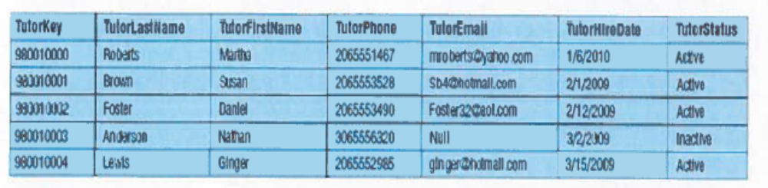

Course
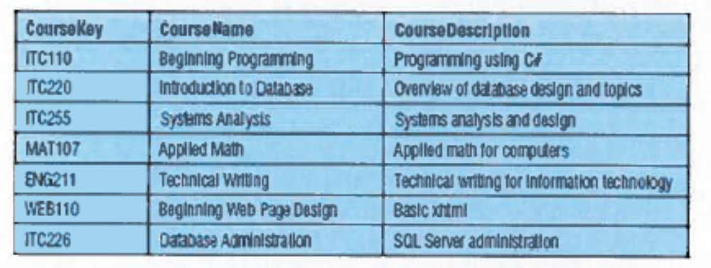
Ethnicity
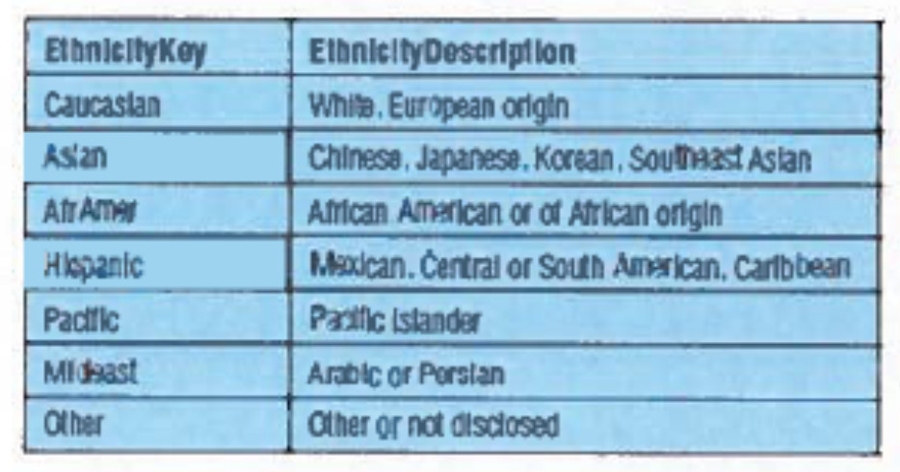

Tutor/Course
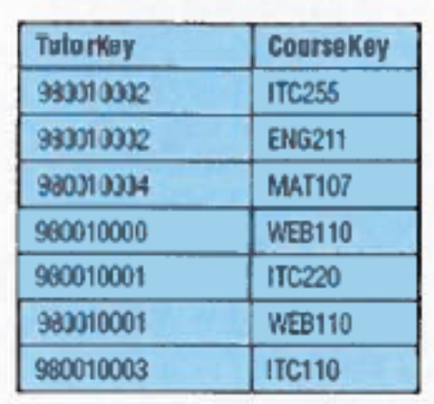
Student:
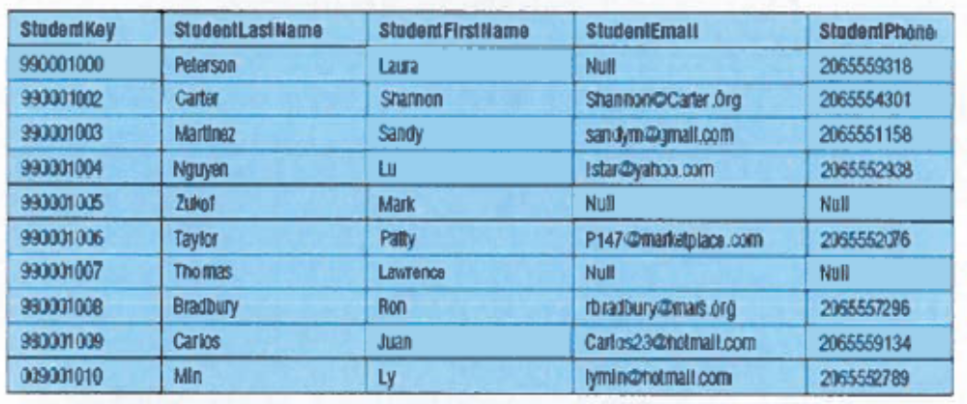
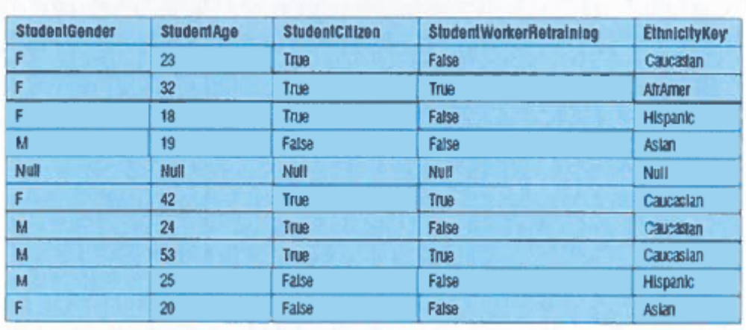
Student/Course
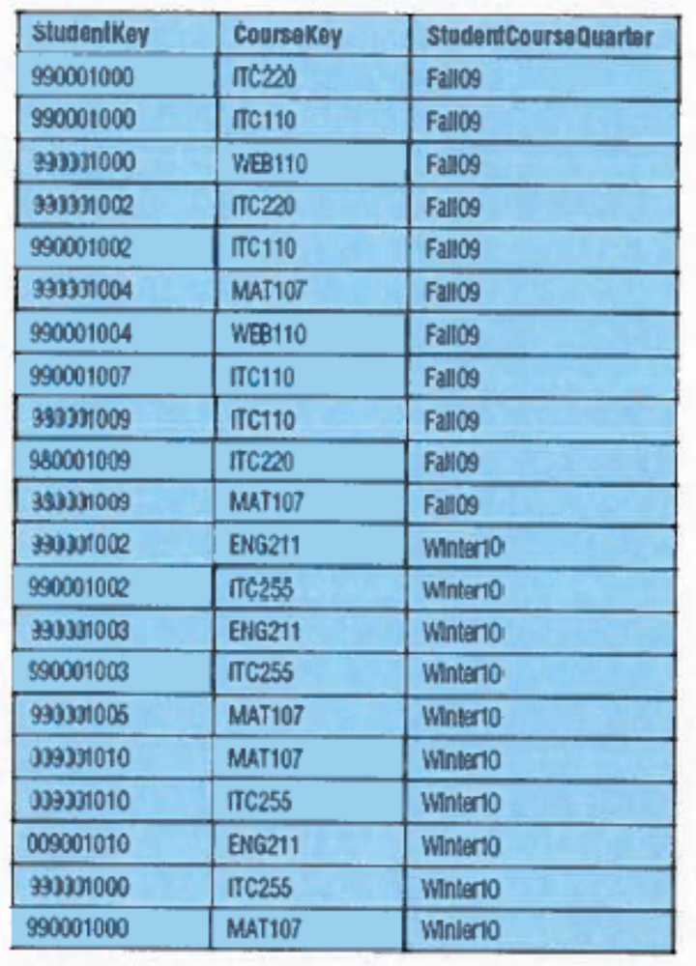
Session
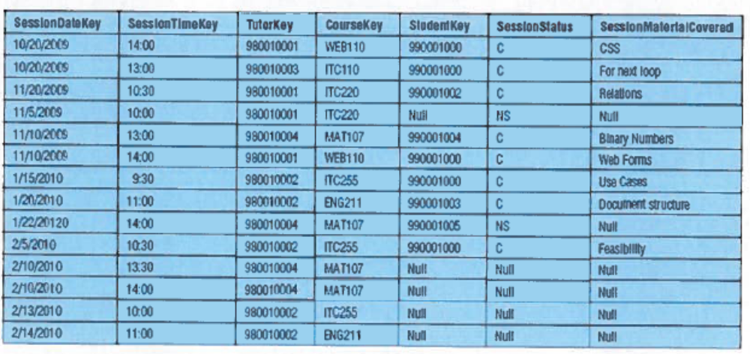
Request
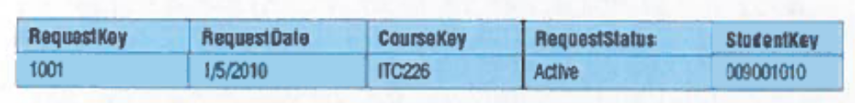

RequestNote
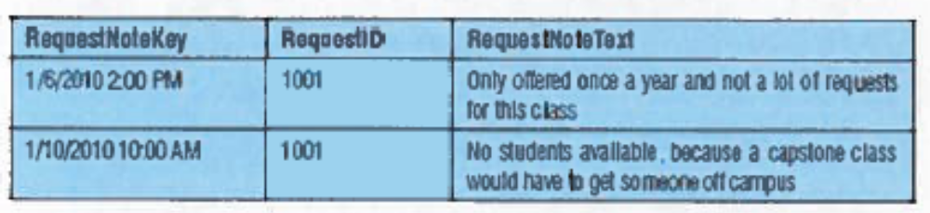
Write the “compilable” SQL query together with the resulting Relation and the tuples in it.
No Relation and tuples- 5 pts

a. (15 points)
Retrieve all male students. Return Last Name, First Name, and Gender.

ANSWER:

b. (15 points)
Retrieve tutor Key, Course KEY, Session Date, and Student Key from scheduled sessions BETWEEN “11/1/2009” and “11/15/2009”.

ANSWER:

c. (15 points)
Retrieve the COUNT of all students over 25 and rename the output Total over 25.

ANSWER:

d. (20 points)
Retrieve tutor Key and number of sessions (rename Total Sessions) of tutors that have less than four sessions scheduled.

ANSWER:

e. (20 points)
No View and tuples- 5 pts
Create a view vw_Sessions for the students to look at the tutoring sessions. It should contain

TutorLastName aliased as [Tutor],
StudentKey AS [Student],
SessionDateKey AS [Date],
SessionTimeKey AS [Time],
CourseKey AS [Course]

ANSWER:

f. (15 points)
Using the View vw_Sessions retrieve the distinct list of tutors.

ANSWER:

